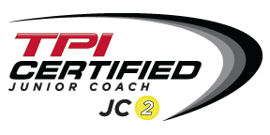
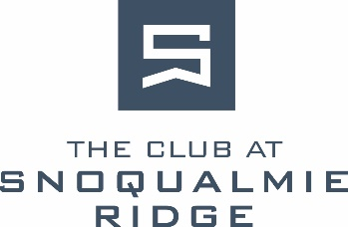
2018 Junior Golf Camp
Summer Registration

Welcome to the 2018 season of summer Junior Golf Performance Camps at The Club at Snoqualmie Ridge… the area’s top golf camp for your junior! Each camp will consist of daily instruction and practice at all aspects of the game as well as TPI based athletic conditioning, rules, etiquette, games and on-course play Tuesday-Thursday (depending on club schedule). Camps will include daily lunch and swimming/free time at the pool. Camps are led by the club’s professional staff as well as local high school and college players. Please indicate which camps you would like your Jr. Golfer to attend:

DATES TIME Sign me up for:

July 23rd – July 26th 9:00 am to 3:00 pm ____________________
July 30th – Aug 3rd 9:00 am to 3:00 pm ____________________
Aug 6th – Aug 9th 9:00 am to 3:00 pm ____________________

Junior Name _________________________________________ Age __________
Parent Name ________________________________________________________
Email _________________________________ Phone ______________________
Experience/ Scores ______________________________________________________

* Member price for each camp is $400. Guest of member is $450.
** Juniors will be participating in various athletic activities including sprinting, running, jumping, hopping, throwing, twisting and swimming. Signing this form indicates you are aware of possible injuries that may occur from kids participating in these activities. Also, please indicate any special medical conditions, group requests, or instructions on back of form or in email to Bryan. Thanks!

